**PROJCT NO : 6**

**AIM:** **Write an appropriate language description for a layman language which can do mathematical operations using English like sentences.**

**EXAMPLE:**

Add 100 ,200,300,400. Sub(Subtract) 250 from result.

Mul(Multiply) 400 to it. Div(Divide) the answer by 2. Show me

the answer.

Lab2: Design DFA and algorithm for assigned language.

**Group Members:**

1. Kathiriya Darshak (IT057)
2. Limbani Nihal (IT064)
3. Karia Stuti (IT055)

**Regular definition for layman Language:**

|  |  |
| --- | --- |
| Regular Defination | Examples: |
| Keywords | From, from, Show, show, by, to, it, result, the, me, Answer, answer |
| Operation | Add, Sub(Subtract), Mul(Multiply), Div(Divide) |
| Digit(Number) | [0-9] |
| Que. Mark | “?”(EOF) |
| White Space | (Tab | Newline)**+** |
| Letter | [A-Za-z] |

**Regular Expression Related to Regular Language**

|  |  |
| --- | --- |
| **Int** | {Digit}+- Atleast one or more Digit |
| **Float** | {Digit}+(\.{Digit}+)?(E[+\-]?{Digit}+)? – Means Digit followed by digit or exponent of 10(digit) |
| **Space** | {white space}+ |

**DFA for given Regular Language:**

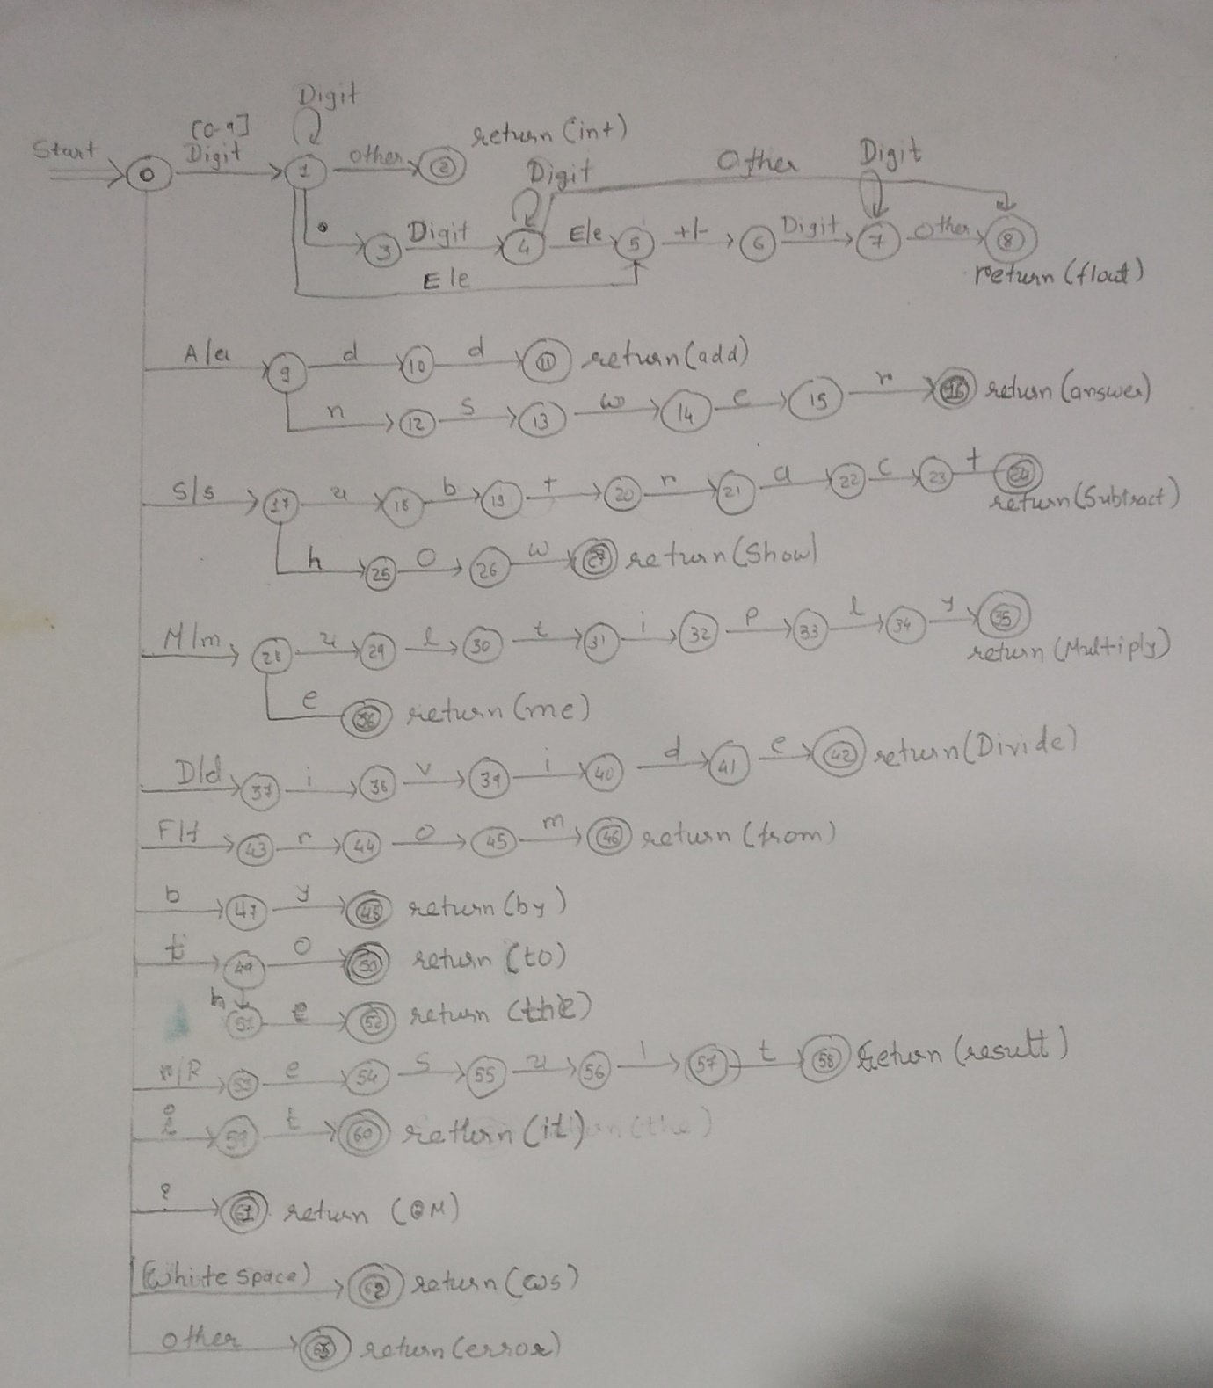

**Algorithms :**

while not eof do

state := 0;

while not eof do

input(ch);

case state of

0:case ch of

digit: state:= 1;

'a'|'A': state:=9;

's'|'S': state:=17;

'm'|'M': state:=28;

'd'|'D': state:=37;

'f'|'F': state:=43;

'b': state:=47;

't': state:=49;

'r'|'R': state:=53;

'i': state:=59;

'?': state:=61;

' '|'\t: state:=62;

else: state:=63;

end case

1:case ch of

digit: state:=1;

'.': state:=3;

'e'|'E': state:=5;

else: state:2;

end case;

2:case ch of

unput(ch);//return int

exit while;

end case;

3:case ch of

digit: state:=4;

else: exit while;

end case;

4:case ch of

digit: state:=4;

'e'|'E': state:=5;

else: state:=8;

end case;

5:case ch of

'+'|'-': state:=6;

else: exit while;

end case;

6:case ch of

digit: state:=7;

else: exit while;

end case;

7:case ch of

digit: state:=7;

else: state:=8;

end case;

8:case ch of

unput(ch);//return float

exit while;

end case;

9:case ch of

'd': state:=10;

'n': state:=12;

else: exit while;

end case;

10:case ch of

'd': state:=11;

else: exit while;

end case;

11:case ch of

unput(ch);//return add

exit while;

end case;

12:case ch of

's': state:=13;

else: exit while;

end case;

13:case ch of

'w': state:=14;

else: exit while;

end case;

14:case ch of

'e': state:=15;

else: exit while;

end case;

15:case ch of

'r': state:=16;

else: exit while;

end case;

16:case ch of

unput(ch);//return answer

exit while;

end case;

17:case ch of

'u': state:=18;

'h': state:=25;

else: exit while;

end case;

18:case ch of

'b': state:=19;

else: exit while;

end case;

19:case ch of

't': state:=20;

else: exit while;

end case;

20:case ch of

'r': state:=21;

else: exit while;

end case;

21:case ch of

'a': state:=22;

else: exit while;

end case;

22:case ch of

'c': state:=23;

else: exit while;

end case;

23:case ch of

't': state:=24;

else: exit while;

end case;

24:case ch of

unput(ch);//return subtract

exit while;

end case;

25:case ch of

'o': state:=26;

else: exit while;

end case;

26:case ch of

'w': state:=27;

else: exit while;

end case;

27:case ch of

unput(ch);//return show

exit while;

end case;

28:case ch of

'u': state:=29;

'e': state:=36;

else: exit while;

end case;

29:case ch of

'l': state:=30;

else: exit while;

end case;

30:case ch of

't': state:=31;

else: exit while;

end case;

31:case ch of

'i': state:=32;

else: exit while;

end case;

32:case ch of

'p': state:=33;

else: exit while;

end case;

33:case ch of

'l': state:=34;

else: exit while;

end case;

34:case ch of

'y': state:=35;

else: exit while;

end case;

35:case ch of

unput(ch);//return multiply

exit while;

end case;

36:case ch of

unput(ch);//return me

exit while;

end case;

37:case ch of

'i': state:=38;

else: exit while;

end case;

38:case ch of

'v': state:=39;

else: exit while;

end case;

39:case ch of

'i': state:=40;

else: exit while;

end case;

40:case ch of

'd': state:=41;

else: exit while;

end case;

41:case ch of

'e': state:=42;

else: exit while;

end case;

42:case ch of

unput(ch);//return divide

exit while;

end case;

43:case ch of

'r': state:=44;

else: exit while;

end case;

44:case ch of

'o': state:=45;

else: exit while;

end case;

45:case ch of

'm': state:=46;

else: exit while;

end case;

46:case ch of

unput(ch);//return from

exit while;

end case;

47:case ch of

'y': state:=48;

else: exit while;

end case;

48:case ch of

unput(ch);//return by

exit while;

end case;

49:case ch of

'o': state:=50;

'h': state:=51;

else: exit while;

end case;

50:case ch of

unput(ch);//return to

exit while;

end case;

51:case ch of

'e': state:=52;

else: exit while;

end case;

52:case ch of

unput(ch);//return the

exit while;

end case;

53:case ch of

'e': state:=54;

else: exit while;

end case;

54:case ch of

's': state:=55;

else: exit while;

end case;

55:case ch of

'u': state:=56;

else: exit while;

end case;

56:case ch of

'l': state:=57;

else: exit while;

end case;

57:case ch of

't': state:=58;

else: exit while;

end case;

58:case ch of

unput(ch);//return result

exit while;

end case;

59:case ch of

't': state:=60;

else: exit while;

end case;

60:case ch of

unput(ch);//return it

exit while;

end case;

61:case ch of

unput(ch);//return QM

exit while;

end case;

62:case ch of

unput(ch);//return WS

exit while;

end case;

63:case ch of

unput(ch);//return OTHER(error)

exit while;

end case;

exit while;